AVR Micro Controller

The AVR is a modified Harvard architecture 8-bit RISC single chip microcontroller which was developed by Atmel in 1996. The AVR was one of the first microcontroller families to use on-chip flash memory for program storage, as opposed to One-Time Programmable ROM, EPROM, or EEPROM used by other microcontrollers at the time.
The AVR architecture was conceived by two students at the Norwegian Institute of Technology (NTH) Alf-Egil Bogen and Vegard Wollan.
The original AVR MCU was developed at a local ASIC house in Trondheim, Norway called Nordic VLSI at the time, now Nordic Semiconductor, where the two founders of Atmel Norway were working as students. It was known as a μRISC (Micro RISC) and was available as silicon IP/building block from Nordic VLSI. When the technology was sold to Atmel from Nordic VLSI, the internal architecture was further developed by Alf and Vegard at Atmel Norway, a subsidiary of Atmel founded by the two architects. The designers worked closely with compiler writers at IAR Systems to ensure that the instruction set provided for more efficient compilation of high-level languages. Atmel says that the name AVR is not an acronym and does not stand for anything in particular. The creators of the AVR give no definitive answer as to what the term "AVR" stands for.
Note that the use of "AVR" in this article generally refers to the 8-bit RISC line of Atmel AVR Microcontrollers.
Among the first of the AVR line was the AT90S8515, which in a 40-pin DIP package has the same pin out as an 8051 microcontroller, including the external multiplexed address and data bus. The polarity of the RESET line was opposite (8051's having an active-high RESET, while the AVR has an active-low RESET), but other than that, the pin out was identical.
- The AVR is a modified Harvard architecture machine with program and data stored in separate physical memory systems that appear in different address spaces, but having the ability to read data items from program memory using special instructions.

Basic families
AVRs are generally classified into five broad groups:
- tinyAVR — the ATtiny series
  - 0.5–8 kB program memory
  - 6–32-pin package
  - Limited peripheral set
- megaAVR — the ATmega series
  - 4–256 kB program memory
  - 28–100-pin package
  - Extended instruction set (Multiply instructions and instructions for handling larger program memories)
  - Extensive peripheral set
- XMEGA — the ATxmega series
  - 16–384 kB program memory
  - 44–64–100-pin package (A4, A3, A1)
  - Extended performance features, such as DMA, "Event System", and cryptography support.
  - Extensive peripheral set with DACs
- Application specific AVR
  - megaAVRs with special features not found on the other members of the AVR family, such as LCD controller, USB controller, advanced PWM, CAN etc.
- FPSLIC™ (AVR with FPGA)

Features of ATMEGA16:

  - High-performance, Low-power AVR® 8-bit Microcontroller
  - Advanced RISC Architecture
    - 131 Powerful Instructions – Most Single-clock Cycle Execution
    - 32 x 8 General Purpose Working Registers
    - Fully Static Operation
    - Up to 16 MIPS Throughput at 16 MHz
    - On-chip 2-cycle Multiplier
  - High Endurance Non-volatile Memory segments
    - 16K Bytes of In-System Self-programmable Flash program memory
    - 512 Bytes EEPROM
    - 1K Byte Internal SRAM
    - Write/Erase Cycles: 10,000 Flash/100,000 EEPROM
    - Data retention: 20 years at 85°C/100 years at 25°C(1)
    - Optional Boot Code Section with Independent Lock Bits
    - In-System Programming by On-chip Boot Program
    - True Read-While-Write Operation
    - Programming Lock for Software Security
  - JTAG (IEEE std. 1149.1 Compliant) Interface
    - Boundary-scan Capabilities According to the JTAG Standard
    - Extensive On-chip Debug Support
    - Programming of Flash, EEPROM, Fuses, and Lock Bits through the JTAG Interface
  - Peripheral Features
    - Two 8-bit Timer/Counters with Separate Prescalers and Compare Modes
    - One 16-bit Timer/Counter with Separate Prescaler, Compare Mode, and Capture Mode
    - Real Time Counter with Separate Oscillator
    - Four PWM Channels
    - 8-channel, 10-bit ADC 8 Single-ended Channels 7 Differential Channels in TQFP Package Only 2 Differential Channels with Programmable Gain at 1x, 10x, or 200x
    - Byte-oriented Two-wire Serial Interface
    - Programmable Serial USART
    - Master/Slave SPI Serial Interface
    - Programmable Watchdog Timer with Separate On-chip Oscillator
    - On-chip Analog Comparator
  - Special Microcontroller Features
    - Power-on Reset and Programmable Brown-out Detection
    - Internal Calibrated RC Oscillator
    - External and Internal Interrupt Sources
    - Six Sleep Modes: Idle, ADC Noise Reduction, Power-save, Power-down, Standby and Extended Standby
  - I/O and Packages
    - 32 Programmable I/O Lines
    - 40-pin PDIP, 44-lead TQFP, and 44-pad QFN/MLF
  - Operating Voltages
    - 2.7 - 5.5V for ATmega16L
    - 4.5 - 5.5V for ATmega16
  - Speed Grades
    - 0 - 8 MHz for ATmega16L
    - 0 - 16 MHz for ATmega16
  - Power Consumption @ 1 MHz, 3V, and 25⋅C for ATmega16L
    - Active: 1.1 mA
    - Idle Mode: 0.35 mA
    - Power-down Mode: < 1 Μa
- Pin Configurations:

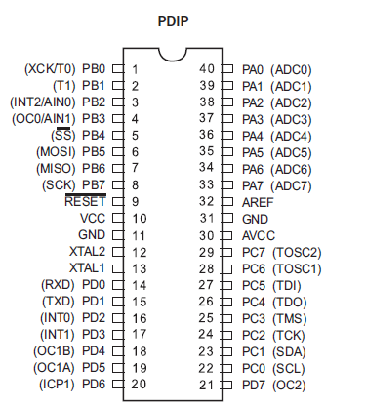

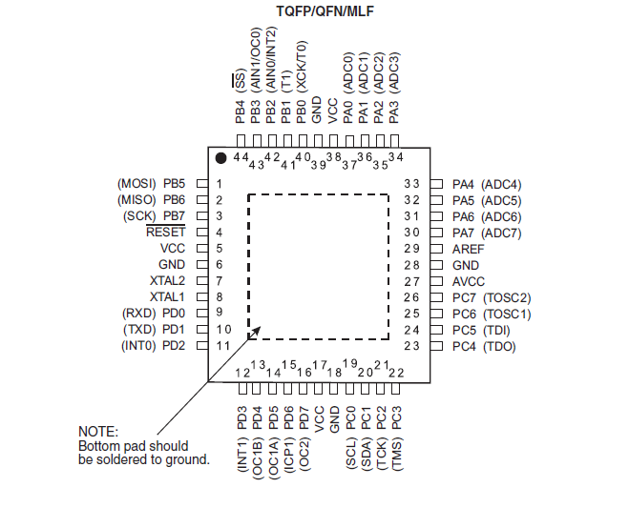
Overview:
The ATmega16 is a low-power CMOS 8-bit microcontroller based on the AVR enhanced RISC architecture. By executing powerful instructions in a single clock cycle, the ATmega16 achieves throughputs approaching 1 MIPS per MHz allowing the system designer to optimize power consumption versus processing speed.
Block Diagram:

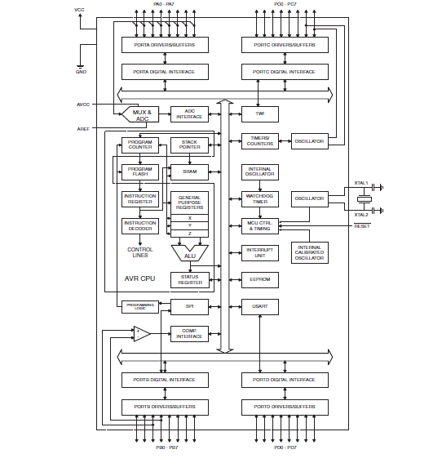

The AVR core combines a rich instruction set with 32 general purpose working registers. All the32 registers are directly connected to the Arithmetic Logic Unit (ALU), allowing two independent registers to be accessed in one single instruction executed in one clock cycle. The resulting architecture is more code efficient while achieving throughputs up to ten times faster than conventional CISC microcontrollers. The ATmega16 provides the following features: 16K bytes of In-System Programmable Flash Program memory with Read-While-Write capabilities, 512 bytes EEPROM, 1K byte SRAM, 32 general purpose I/O lines, 32 general purpose working registers, a JTAG interface for Boundary scan,
On-chip Debugging support and programming, three flexible Timer/Counters with compare modes, Internal and External Interrupts, a serial programmable USART, a byte oriented Two-wire Serial Interface, an 8-channel, 10-bit ADC with optional differential input stage with programmable gain (TQFP package only), a programmable Watchdog Timer with Internal Oscillator, an SPI serial port, and six software selectable power saving modes. The Idle mode stops the CPU while allowing the USART, Two-wire interface, A/D Converter, SRAM, Timer/Counters, SPI port, and interrupt system to continue functioning. The Power-down mode saves the register contents but freezes the Oscillator, disabling all other chip functions until the next External Interrupt or Hardware Reset. In Power-save mode, the Asynchronous Timer continues to run, allowing the user to maintain a timer base while the rest of the device is sleeping. The ADC Noise Reduction mode stops the CPU and all I/O modules except Asynchronous Timer and ADC, to minimize switching noise during ADC conversions. In Standby mode, the crystal/resonator Oscillator is running while the rest of the device is sleeping. This allows very fast start-up combined with low-power consumption. In Extended Standby mode, both the main Oscillator and the Asynchronous Timer continue to run. The device is manufactured using Atmel’s high density nonvolatile memory technology. The Onchip ISP Flash allows the program memory to be reprogrammed in-system through an SPI serial interface, by a conventional nonvolatile memory programmer, or by an On-chip Boot program running on the AVR core. The boot program can use any interface to download the application program in the Application Flash memory. Software in the Boot Flash section will continue to run while the Application Flash section is updated, providing true Read-While-Write operation. By combining an 8-bit RISC CPU with In-System Self-Programmable Flash on a monolithic chip, the Atmel ATmega16 is a powerful microcontroller that provides a highly-flexible and cost-effective solution to many embedded control applications. The ATmega16 AVR is supported with a full suite of program and system development tools including: C compilers, macro assemblers, program debugger/simulators, in-circuit emulators, and evaluation kits.
Pin Descriptions:

VCC:
Digital supply voltage.

GND:
Ground.

Port A (PA7.PA0):
Port A serves as the analog inputs to the A/D Converter. Port A also serves as an 8-bit bi-directional I/O port, if the A/D Converter is not used. Port pins can provide internal pull-up resistors (selected for each bit). The Port A output buffers have symmetrical drive characteristics with both high sink and source capability. When pins PA0 to PA7 are used as inputs and are externally pulled low, they will source current if the internal pull-up resistors are activated. The Port A pins are tri-stated when a reset condition becomes active, even if the clock is not running.
Port B (PB7.PB0):

Port B is an 8-bit bi-directional I/O port with internal pull-up resistors (selected for each bit). The Port B output buffers have symmetrical drive characteristics with both high sink and source Capability. As inputs, Port B pins that are externally pulled low will source current if the pull-up Resistors are activated. The Port B pins are tri-stated when a reset condition becomes active, even if the clock is not running. Port B also serves the functions of various special features of the ATmega16 as listed on
Port C (PC7.PC0):

Port C is an 8-bit bi-directional I/O port with internal pull-up resistors (selected for each bit). The Port C output buffers have symmetrical drive characteristics with both high sink and source capability. As inputs, Port C pins that are externally pulled low will source current if the pull-up resistors are activated. The Port C pins are tri-stated when a reset condition becomes active, even if the clock is not running. If the JTAG interface is enabled, the pull-up resistors on pins PC5(TDI), PC3(TMS) and PC2(TCK) will be activated even if a reset occurs. Port C also serves the functions of the JTAG interface and other special features of the ATmega16 as listed on

Port D (PD7.PD0):

Port D is an 8-bit bi-directional I/O port with internal pull-up resistors (selected for each bit). The Port D output buffers have symmetrical drive characteristics with both high sink and source capability. As inputs, Port D pins that are externally pulled low will source current if the pull-up resistors are activated. The Port D pins are tri-stated when a reset condition becomes active, even if the clock is not running. Port D also serves the functions of various special features of the ATmega16 as listed on
RESET:

Reset Input. Low levels on this pin for longer than the minimum pulse length will generatereset, even if the clock is not running. The minimum pulse length is given in Shorter pulses are not guaranteed to generate a reset.
XTAL1:

Input to the inverting Oscillator amplifier and input to the internal clock operating circuit.
XTAL2:
Output from the inverting Oscillator amplifier.
AVCC:
AVCC is the supply voltage pin for Port A and the A/D Converter. It should be externally connected to VCC, even if the ADC is not used. If the ADC is used, it should be connected to VCC through a low-pass filter.AREF AREF is the analog reference pin for the A/D Converter.
AVR CPU Core Introduction:

This section discusses the AVR core architecture in general. The main function of the CPU core is to ensure correct program execution. The CPU must therefore be able to access memories, perform calculations, control peripherals, and handle interrupts.
Architectural Overview:
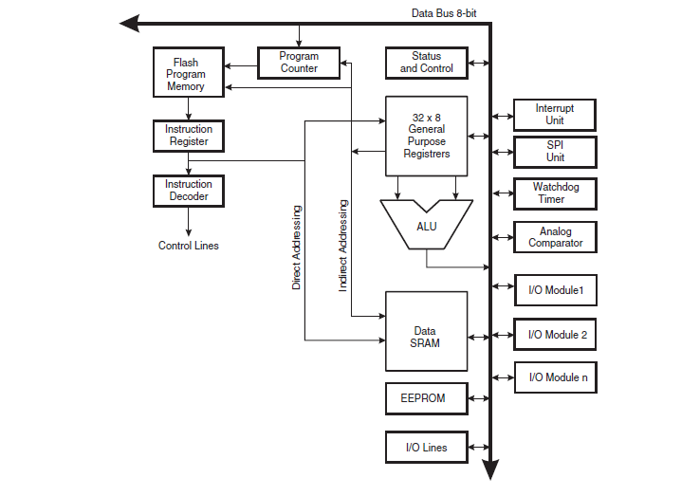
In order to maximize performance and parallelism, the AVR uses a Harvard architecture – with +separate memories and buses for program and data. Instructions in the program memory are executed with a single level pipelining. While one instruction is being executed, the next instruction is pre-fetched from the program memory. This concept enables instructions to be executed in every clock cycle. The program memory is In-System Reprogrammable Flash memory. The fast-access Register File contains 32 x 8-bit general purpose working registers with a single clock cycle access time. This allows single-cycle Arithmetic Logic Unit (ALU) operation. In a typical ALU operation, two operands are output from the Register File, the operation is executed, and the result is stored back in the Register File – in one clock cycle. Six of the 32 registers can be used as three 16-bit indirect address register pointers for Data Space addressing – enabling efficient address calculations. One of the these address pointers can also be used as an address pointer for look up tables in Flash Program memory. These added function registers are the 16-bit X-, Y-, and Z-register, described later in this section. The ALU supports arithmetic and logic operations between registers or between a constant and a register. Single register operations can also be executed in the ALU. After an arithmetic operation, the Status Register is updated to reflect information about the result of the operation. Program flow is provided by conditional and unconditional jump and call instructions, able to directly address the whole address space. Most AVR instructions have a single 16-bit word format. Every program memory address contains a 16- or 32-bit instruction.
ALU – Arithmetic Logic Unit:

The high-performance AVR ALU operates in direct connection with all the 32 general purpose Working registers. Within a single clock cycle, arithmetic operations between general purpose Registers or between a register and an immediate are executed. The ALU operations are divided into three main categories – arithmetic, logical, and bit-functions. Some implementations of the Architecture also provide a powerful multiplier supporting both signed/unsigned multiplication And fractional format. See the “Instruction Set” section for a detailed description

Status Register:

The Status Register contains information about the result of the most recently executed arithmetic instruction. This information can be used for altering program flow in order to perform conditional operations. Note that the Status Register is updated after all ALU operations, as specified in the Instruction Set Reference. This will in many cases remove the need for using the dedicated compare instructions, resulting in faster and more compact code. The Status Register is not automatically stored when entering an interrupt routine and restored when returning from an interrupt. This must be handled by software. The AVR Status Register – SREG – is defined as:

• Bit 7 – I: Global Interrupt Enable

The Global Interrupt Enable bit must be set for the interrupts to be enabled. The individual interrupt enable control is then performed in separate control registers. If the Global Interrupt Enable Register is cleared, none of the interrupts are enabled independent of the individual interrupt enable settings. The I-bit is cleared by hardware after an interrupt has occurred, and is set by the RETI instruction to enable subsequent interrupts. The I-bit can also be set and cleared by the application with the SEI and CLI instructions, as described in the instruction set reference.
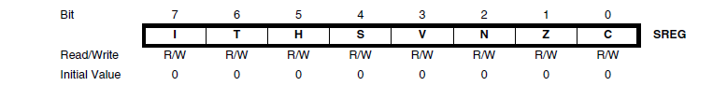

ATmega16

• Bit 6 – T: Bit Copy Storage

The Bit Copy instructions BLD (Bit LoaD) and BST (Bit STore) use the T-bit as source or destination for the operated bit. A bit from a register in the Register File can be copied into T by the BST instruction, and a bit in T can be copied into a bit in a register in the Register File by the BLD instruction.
• Bit 5 – H: Half Carry Flag

The Half Carry Flag H indicates a Half Carry in some arithmetic operations. Half Carry is useful in BCD arithmetic. See the “Instruction Set Description” for detailed information.
• Bit 4 – S: Sign Bit, S = N ⊕ V

The S-bit is always an exclusive or between the Negative Flag N and the Two’s Complement
Overflow Flag V. See the “Instruction Set Description” for detailed information.
• Bit 3 – V: Two’s Complement Overflow Flag

The Two’s Complement Overflow Flag V supports two’s complement arithmetics. See the
“Instruction Set Description” for detailed information.
• Bit 2 – N: Negative Flag

The Negative Flag N indicates a negative result in an arithmetic or logic operation. See the
“Instruction Set Description” for detailed information.
• Bit 1 – Z: Zero Flag

The Zero Flag Z indicates a zero result in an arithmetic or logic operation. See the “Instruction Set Description” for detailed information.
• Bit 0 – C: Carry Flag

The Carry Flag C indicates a carry in an arithmetic or logic operation. See the “Instruction Set Description” for detailed information.
General Purpose Register File:

The Register File is optimized for the AVR Enhanced RISC instruction set. In order to achieve the required performance and flexibility, the following input/output schemes are supported by the Register File:
• One 8-bit output operand and one 8-bit result input
• Two 8-bit output operands and one 8-bit result input
• Two 8-bit output operands and one 16-bit result input
